**Project Design Phase-II**

**Technology Stack (Architecture & Stack)**

|  |  |
| --- | --- |
| Date | 31 October 2022 |
| Team ID | PNT2022TMID18041 |
| Project Name | Hazardous Area Monitoring for Industrial Plant powered by IoT |
| Maximum Marks | 4 Marks |

**Technical Architecture:**

**Example:** Hazardous Area Monitoring for Industrial Plant powered by IoT

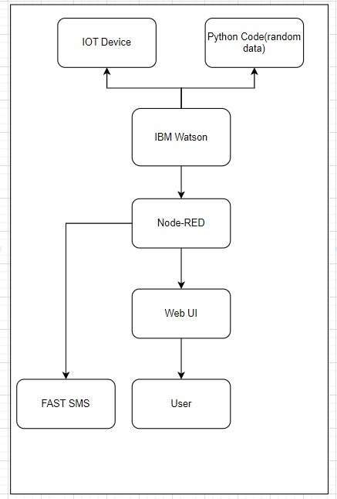

**Table-1 : Components & Technologies:**

|  |  |  |  |
| --- | --- | --- | --- |
| **S.No** | **Component** | **Description** | **Technology** |
| 1. | User Interface | Web UI, Mobile App | HTML, CSS, JavaScript / Angular Js / React Js etc. |
| 2. | Application Logic-1 | Logic for a process in the application | Java / Python |
| 3. | Application Logic-2 | Logic for a process in the application | IBM Watson STT service |
| 4. | Application Logic-3 | Logic for a process in the application | IBM Watson Assistant |
| 5. | Database | Data Type | MySQL, NoSQL |
| 6. | Cloud Database | Database Service on Cloud | IBM Cloudant etc. |
| 7. | File Storage | File storage requirements | IBM Block Storage |
| 8. | Machine Learning Model | Purpose of Machine Learning Model | Object Recognition Model, etc. |
| 9. | Infrastructure (Server / Cloud) | Application Deployment on Local System / Cloud  Local Server Configuration:  Cloud Server Configuration : | Local, Cloud Foundry, Kubernetes, etc. |

**Table-2: Application Characteristics:**

|  |  |  |  |
| --- | --- | --- | --- |
| **S.No** | **Characteristics** | **Description** | **Technology** |
| 1. | Open-Source Frameworks | The open-source frameworks used | Chrome |
| 2. | Security  Implementations | The security / access controls implemented, use of firewalls etc. | IBM cloud Encryptions |
| 3. | Scalable  Architecture | The scalability of architecture (3 – tier, Micro-services) | IBM cloud architecture |
| 4. | Availability | The availability of application (e.g. use of load balancers, distributed servers etc.) | Web application can even be used by the workers in the industry |
| 5. | Performance | The performance of the application (number of requests per sec, use of Cache, use of CDN’s) etc. | Since the web application is high efficient, it can be used by the workers irrespective of time. |